*Farahin Choudhury*

*IST659 | M403 | Winter 2021*

*Video platform project outline*

Final Project

Project Outline

1. **Overview**
   1. In this project, trends on a social media video-sharing platform similar to TikTok and YouTube will be analyzed. The attributes of the entities in this model will be related to specific elements that make a video very popular. The model will include details of videos that went viral, including the most important attribute which is the number of views on the videos. The type of content of these videos vary widely and have a dynamic audience and reach. Many of the interactions in this model involve the video creator and the user, which are two distinct entities, as one is content provider and the other consumes the content. This project will have clearly defined rules and parameters regarding creators and the algorithm that controls the flow of videos. The algorithm can show recommended videos based on similar videos created around a certain topic or trend. It can also recommend videos that have generally been performing well on the platform since the time of its publication. The overarching purpose of this project is to analyze videos that have performed well as per the metrics set by the business rules and how one can implement these rules and other techniques to create videos of a similar caliber on this platform.
2. **Research questions** 
   1. Which are each of the creators’ longest videos? What are the corresponding tags of the longest videos?
   2. Which top 3 creators are not verified but have the highest number of views?
   3. How long (years or months) has the verified account with the most subscribers been active on the platform? How long (years or months) has the unverified account with the most subscribers been active on the platform?
   4. What is the average length of a video for each creator?
   5. Are there videos that have the same hashtag?
   6. Based on the videos viewed by the users, which creators are preferred by the users (determined by the videos from each creator that the user views on the platform)?
3. **Stakeholders** 
   1. User
   2. Creator (no longer a user after 1000 followers)
   3. Platform: houses the videos and recommends videos to its users and encourages consistent usage
4. **Entities and relationships**
   1. An account can have many followers and users can follow as many accounts as they want (many to many relationship)
   2. A unique video can only be created by a unique creator but a creator can make many videos on his/her account (one to many relationship)
   3. A user can have multiple accounts on the platform but the accounts can be managed by only one person (many to one relationship)
      1. The caveat would be that if the account belongs to a business, then several people may get access to that one account
   4. The algorithm, which controls the videos that show up on the main homepage of the platform, presents a very unique and complicated relationship in this model. The algorithm is one overarching entity that can generally only have one-to-many relationships with the videos on the platform. The algorithm recommends many videos for users to watch but videos can only be recommended by one entity, which is the algorithm.
   5. The platform is the entity that houses all the videos created on it by Creators. This is another example where there is a one-to many relationship: the platform contains/houses the videos and the videos are located/can be found on the platform. This is the only platform that the video can be created on, making the video itself a unique entity.
5. **Business rules** 
   1. Anyone can have a profile on the platform.
   2. A user becomes a creator once they reach 500 followers on the platform.
   3. At the time a creator reaches the 1000-follower milestone, he/she will become a verified profile (signified by a star next to their name).
   4. There is only 1 platform on which the video is created and published.
   5. There is only 1 algorithm that exists and controls the way videos appear on the platform.
   6. Videos can have up to 5 hashtags, which make them easier to discover. Certain hashtags that are trending at the moment will be more likely to appear on the “recommended” section of the platform.
   7. There are community guidelines in place for everyone to have a pleasant experience on the app. Users could run the risk of having their access to the platform revoked or worse; they could be become barred from using the platform if they do not adhere to the guidelines or disregard any warnings.
   8. Creators may create any kind of content they desire, but they will not be able to use the platform for hate speech or target a certain group of people and admonish them for any reason. Hashtags can help to determine what a video is about. The algorithm can also be set up to automatically remove videos that go against the community guidelines.

Glossary

1. **User**: This is both an entity and a stakeholder in this model.
2. **Creator**: This is an entity signified by the number of followers on the platform and the verification of the account on the platform
3. **The** **platform**: The entity where all the interactions happen with its users and the videos. It has an interface that is designed to be easily navigated by its users.
4. **The algorithm**: A back-end script with code that controls the way videos get shared and discovered on the platform
5. **Video**: The type of media that can be found on the platform.
6. **Account**: A profile on the platform owned by users and creators. This can only be accessed by the User or Creator.
7. **Viral**: This is a term used often in this model to describe a video that is popular and has garnered a sizable following on the platform.
8. **Hashtag**: This is a feature on a video that relates to the content of the video. On the platform, users may search for hashtags and a list will return with the relevant hashtag.
9. **Publication Date:** This is the date that the video was published on the platform
10. **Video Length:** This is how long the video is, measured in seconds
11. **Followers:** This is the number of followers that a creator has
12. **Video count:** This is the number of videos on a creator’s account
13. **Video Count:** This is the number of videos on the platform
14. **Recommended Videos:** This is the count of videos that are recommended on the platform by the algorithm
15. **Like Count:** this is the number of likes that a video has
16. **Tag usage count:** This is the number of times a hashtag has been used across all the videos on the platform
17. **Creator Count:** This is the aggregate count of the creators that currently exist on the platform

**Conceptual model diagram:**

**Logical model diagram (below):**

**Tableau charts/visualizations**

**Counting the number of followers for both verified and unverified creators**

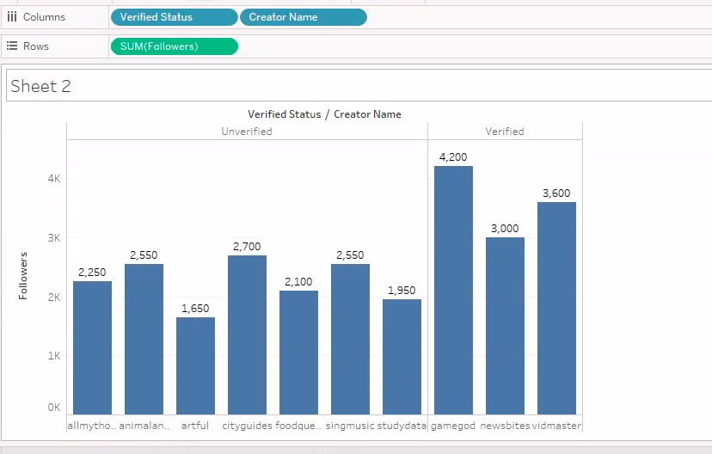

**Ordering the videos by video length (longest to shortest video on the platform)**

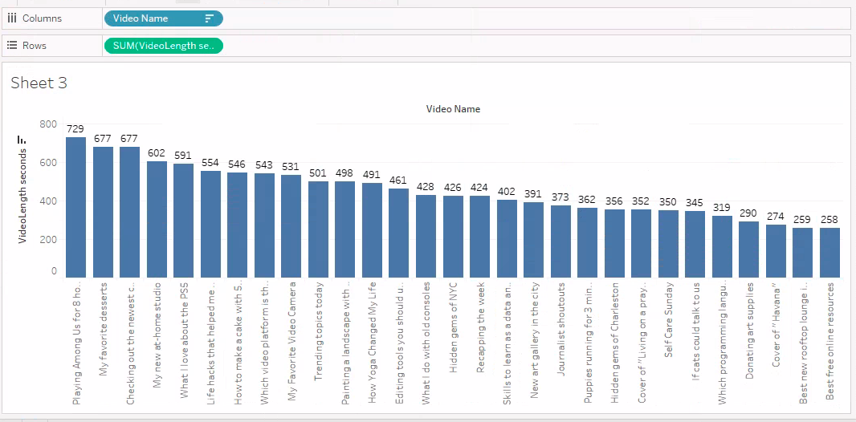

**Finding the average video length in seconds per creator on the platform**

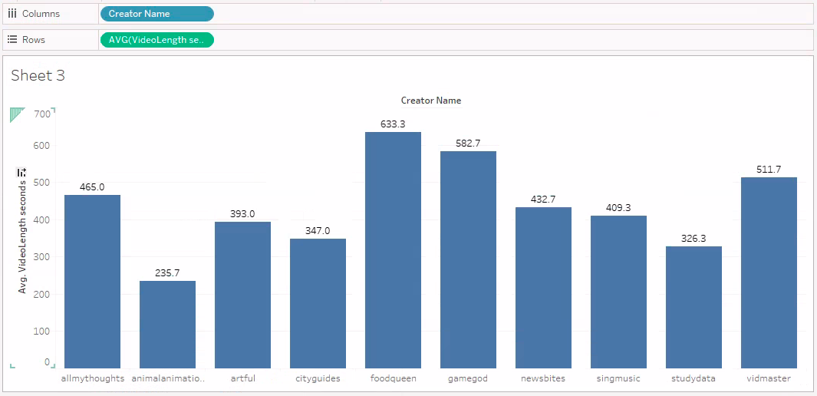

**Illustrating the creators’ follower count**

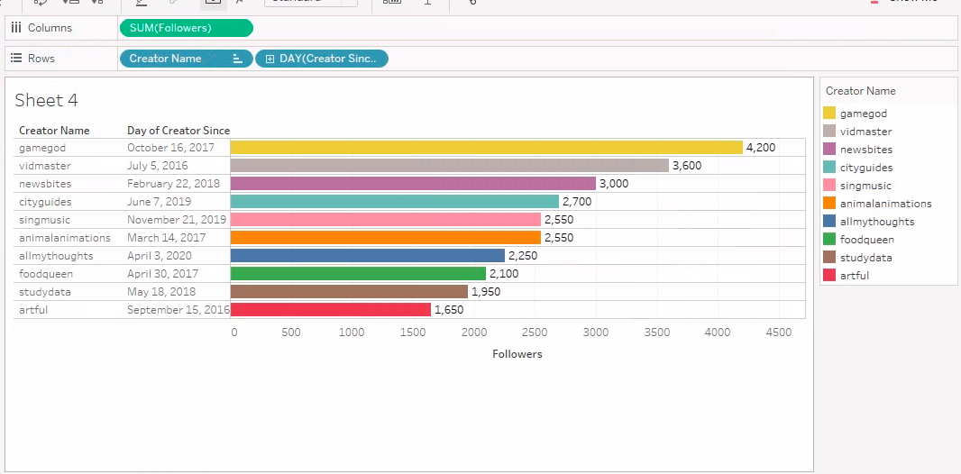

**Calculating average video length in minutes per creator**

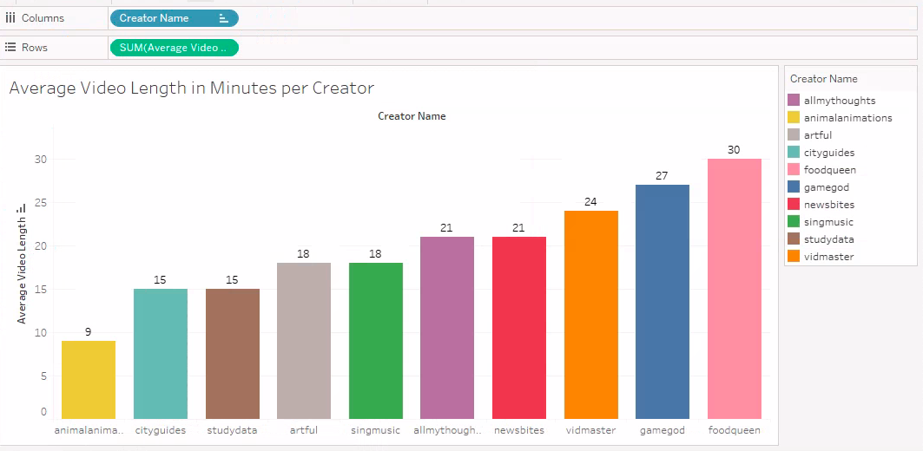

**Videos viewed by User, organized by creator ID**

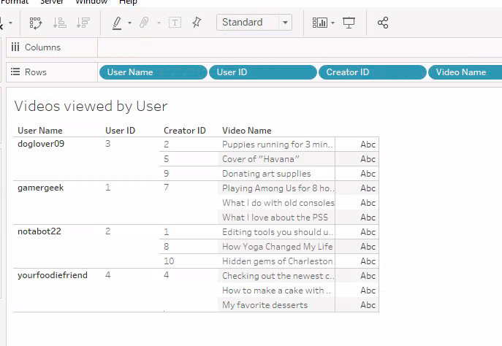

**Tags per video- Are there videos on this platform with the same tags?**

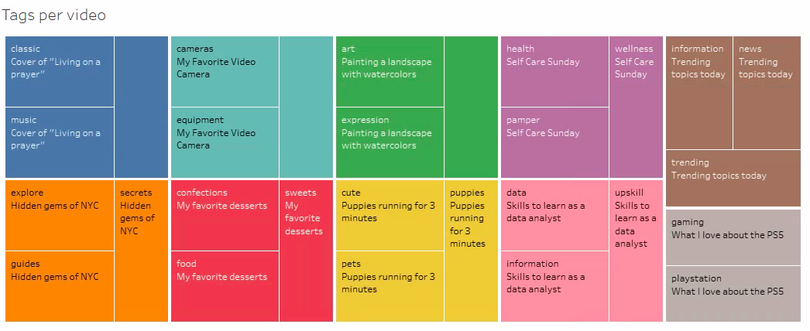

**Form created in Microsoft Access to update a table (in this case, User):**

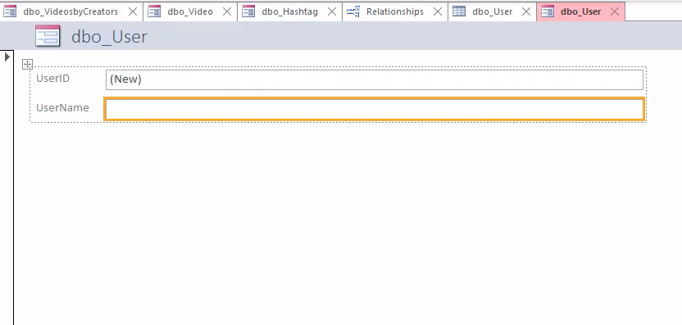

**Also for Hashtag:**

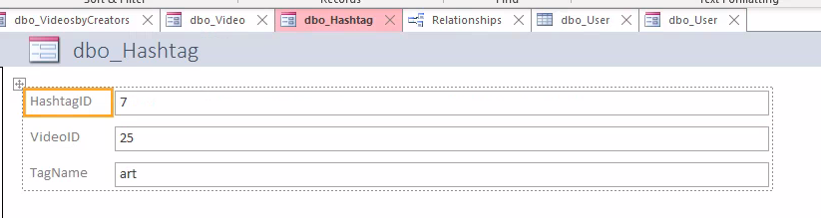

**Summary**

This was a fully ornamented database created from scratch with artificial data meant to mirror a database with many rows and records. I envisioned this project to be more straightforward than it turned out to be. However, such is the nature of fully ornamented databases, there were some key findings from the data in this database. While the scope was narrowed since the first milestone of this project, it was still interesting to see how it all came together. For my visualizations, I was able to connect my database to Tableau, which produced neat and easy-to-understand visuals.

**Reflection**While this project was challenging to work through, it was a great learning moment. Every single lesson from this quarter was implemented which allowed for the complexity that this database and model display. I have had to scale back on the scope of my project to not make it as complicated as it would’ve turned out. For example I originally had tables for Partnerships and Advertisers which would be connected to the creators but it started to get really confusing. I also didn’t have data questions that could be adequately answered if these tables were created. There were also columns in some tables that I got rid of completely because they didn’t make sense to include after all and it would further complicate things. I am satisfied with the visualizations that were produced in Tableau, even if some of them were less “interesting” than others. As previously mentioned, I had to change the scope of my project and ended up having to create different research questions based on the data that was available.